New Wheels Project

Data Querying and Analytic with SQL

Problem Statement
Business Context
A lot of people in the world share a common desire: to own a vehicle. A car or an automobile is seen as an object that gives the freedom of mobility. Many now prefer pre-owned vehicles because they come at an affordable cost, but at the same time, they are also concerned about whether the after-sales service provided by the resale vendors is as good as the care you may get from the actual manufacturers.
New-Wheels, a vehicle resale company, has launched an app with an end-to-end service from listing the vehicle on the platform to shipping it to the customer's location. This app also captures the overall after-sales feedback given by the customer.
Objective
New-Wheels sales have been dipping steadily in the past year, and due to the critical customer feedback and ratings online, there has been a drop in new customers every quarter, which is concerning to the business. The CEO of the company now wants a quarterly report with all the key metrics sent to him so he can assess the health of the business and make the necessary decisions.
As a data analyst, you see that there is an array of questions that are being asked at the leadership level that need to be answered using data. Import the dump file that contains various tables that are present in the database. Use the data to answer the questions posed and create a quarterly business report for the CEO.

Business Questions

Question 1: Find the total number of customers who have placed orders. What is the distribution of the customers across states?
Solution Query:
SELECT
COUNT(DISTINCT customer_id) AS count
FROM order_t;
SELECT
c.state,
COUNT(DISTINCT o.customer_id) AS count
FROM order_t AS o
INNER JOIN customer_t AS c
ON o.customer_id = c.customer_id
GROUP BY c.state
ORDER BY count DESC;
Output:
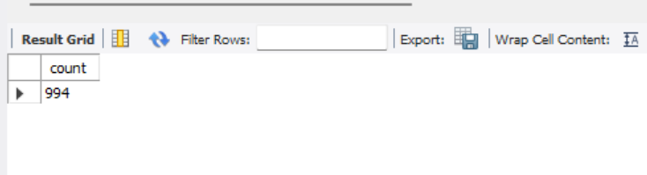
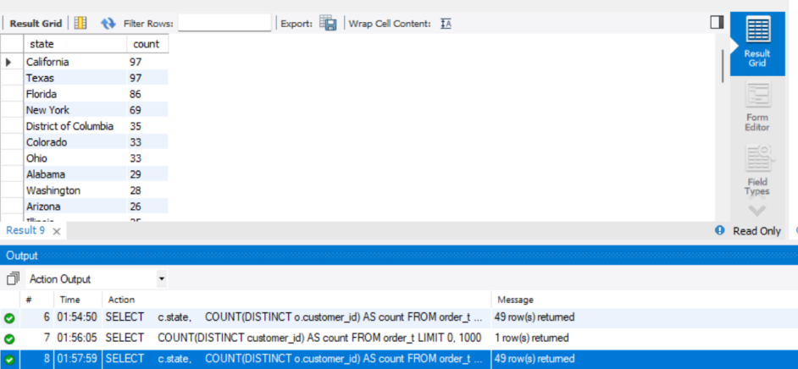

Observation:
A total of 994 customers placed orders. The highest customer concentration is in California and Texas, with 97 customers each, followed by Florida with 86 customers and New York with 69 customers.
Insight:
New-Wheels has strong customer presence in large states like California, Texas, Florida, and New York. These states should be prioritized for marketing, logistics, and customer support improvements.
Question 2: Which are the top 5 vehicle makers preferred by the customers?
Solution Query:
SELECT
p.vehicle_maker AS vehicle_maker,
COUNT(DISTINCT o.customer_id) AS customer_count
FROM order_t AS o
INNER JOIN product_t AS p
ON o.product_id = p.product_id
GROUP BY p.vehicle_maker
ORDER BY customer_count DESC, p.vehicle_maker
LIMIT 5;
Output:
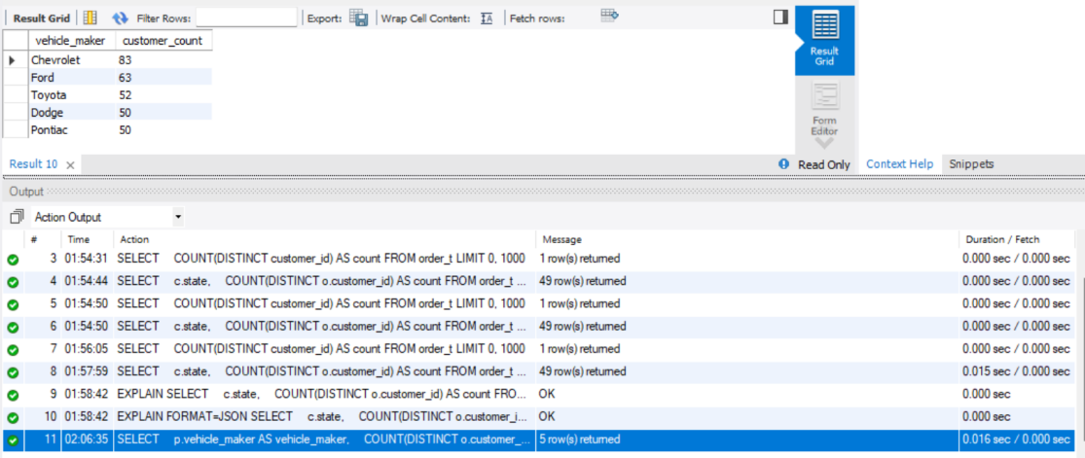

Observation and Insight:
Chevrolet is the most preferred vehicle maker, with 83 customers, followed by Ford with 63 customers and Toyota with 52 customers. Dodge and Pontiac are tied with 50 customers each.
This shows that customer demand is concentrated around a few major vehicle makers. New-Wheels should maintain stronger inventory availability and after-sales support for high-demand brands such as Chevrolet, Ford, and Toyota.
Question 3: Which is the most preferred vehicle maker in each state?
Solution Query:
WITH maker_state_counts AS (
SELECT
c.state AS state,
p.vehicle_maker AS vehicle_maker,
COUNT(DISTINCT o.customer_id) AS customer_count
FROM order_t AS o
INNER JOIN customer_t AS c
ON o.customer_id = c.customer_id
INNER JOIN product_t AS p
ON o.product_id = p.product_id
GROUP BY c.state, p.vehicle_maker
),
ranked_makers AS (
SELECT
state,
vehicle_maker,
customer_count,
RANK() OVER (
PARTITION BY state
ORDER BY customer_count DESC
) AS maker_rank
FROM maker_state_counts
)
SELECT
state,
vehicle_maker,
customer_count
FROM ranked_makers
WHERE maker_rank = 1
ORDER BY state, vehicle_maker;
Output:
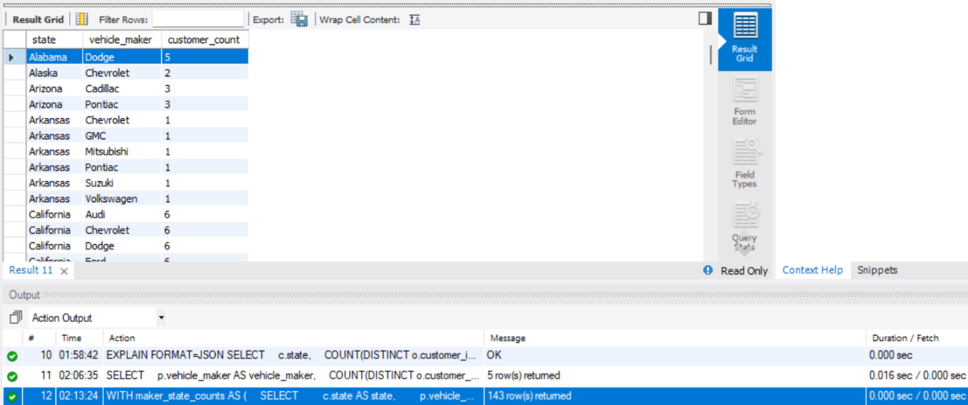
Observation:
The most preferred maker differs by state. Some states have multiple top makers because there are ties. For example, in California, brands like Audi, Chevrolet, Dodge, Ford, and Nissan are tied with the highest customer count.
Insight:
Customer vehicle preference is region-specific. New-Wheels should use state-level demand patterns to plan inventory instead of applying the same vehicle mix across all states. For states with tied preferences, the company can stock multiple leading brands to avoid losing customers due to limited options.

Question 4: Find the overall average rating given by the customers. What is the average rating in each quarter?

Consider the following mapping for ratings: “Very Bad”: 1, “Bad”: 2, “Okay”: 3, “Good”: 4, “Very Good”: 5
Solution Query:
WITH feedback_scores AS (
SELECT
quarter_number,
CASE customer_feedback
WHEN 'Very Bad' THEN 1
WHEN 'Bad' THEN 2
WHEN 'Okay' THEN 3
WHEN 'Good' THEN 4
WHEN 'Very Good' THEN 5
END AS rating_score
FROM order_t
)
SELECT
'Overall' AS period,
ROUND(AVG(rating_score), 2) AS average_rating
FROM feedback_scores
UNION ALL
SELECT
'Q' || quarter_number AS period,
ROUND(AVG(rating_score), 2) AS average_rating
FROM feedback_scores
GROUP BY quarter_number
ORDER BY period;
Output:
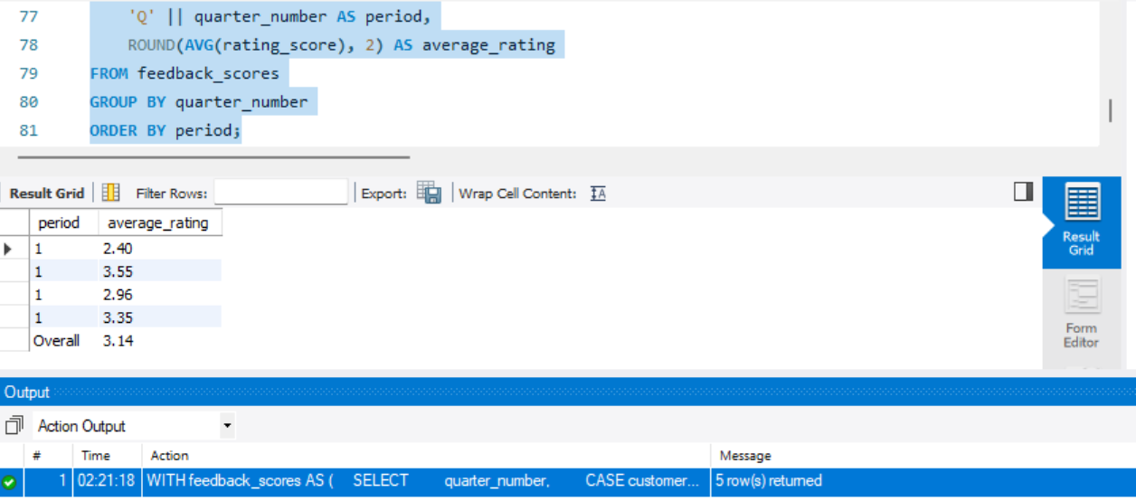

Observation and Insight:

The overall average rating is 3.13, which is slightly above neutral. However, the quarter-wise trend shows a continuous decline in customer satisfaction. The average rating dropped from 3.55 in Q1 to 2.40 in Q4.

This indicates that customer experience is getting worse over time. The decline in ratings may be linked to operational issues such as delayed shipping, poor after-sales service, or unmet customer expectations. New-Wheels should investigate the causes of lower ratings, especially in Q3 and Q4.

Question 5: Find the percentage distribution of feedback from the customers. Are customers getting more dissatisfied over time?
Solution Query:
SELECT
quarter_number,
ROUND(100.0 * SUM(CASE WHEN customer_feedback = 'Very Bad' THEN 1 ELSE 0 END) / COUNT(*), 2) AS very_bad_pct,
ROUND(100.0 * SUM(CASE WHEN customer_feedback = 'Bad' THEN 1 ELSE 0 END) / COUNT(*), 2) AS bad_pct,
ROUND(100.0 * SUM(CASE WHEN customer_feedback = 'Okay' THEN 1 ELSE 0 END) / COUNT(*), 2) AS okay_pct,
ROUND(100.0 * SUM(CASE WHEN customer_feedback = 'Good' THEN 1 ELSE 0 END) / COUNT(*), 2) AS good_pct,
ROUND(100.0 * SUM(CASE WHEN customer_feedback = 'Very Good' THEN 1 ELSE 0 END) / COUNT(*), 2) AS very_good_pct
FROM order_t
GROUP BY quarter_number
ORDER BY quarter_number;
Output:
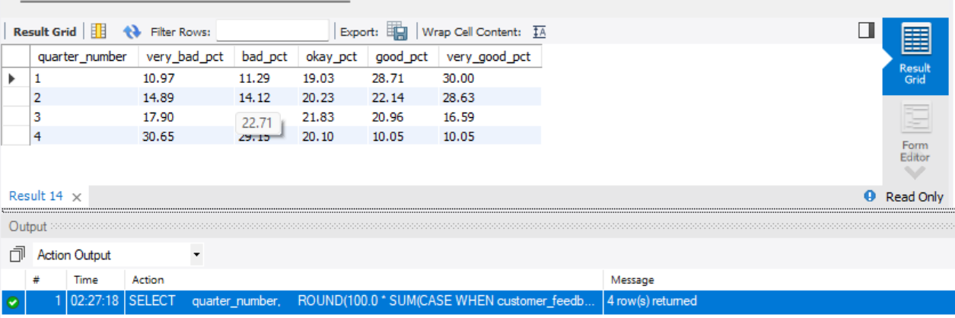

Observation and Insight:

Customers are clearly becoming more dissatisfied over time. The percentage of Very Bad feedback increased from 10.97% in Q1 to 30.65% in Q4. Similarly, Bad feedback increased from 11.29% in Q1 to 29.15% in Q4.

Positive feedback declined sharply. Very Good feedback dropped from 30.00% in Q1 to only 10.05% in Q4, and Good feedback dropped from 28.71% to 10.05%.

This shows a serious decline in customer satisfaction. New-Wheels should urgently investigate service issues, especially shipping delays and after-sales support, because negative feedback is increasing every quarter.

Question 6: What is the trend of the number of orders by quarter?
Solution Query:
SELECT
quarter_number,
COUNT(order_id) AS total_orders
FROM order_t
GROUP BY quarter_number
ORDER BY quarter_number;
Output:
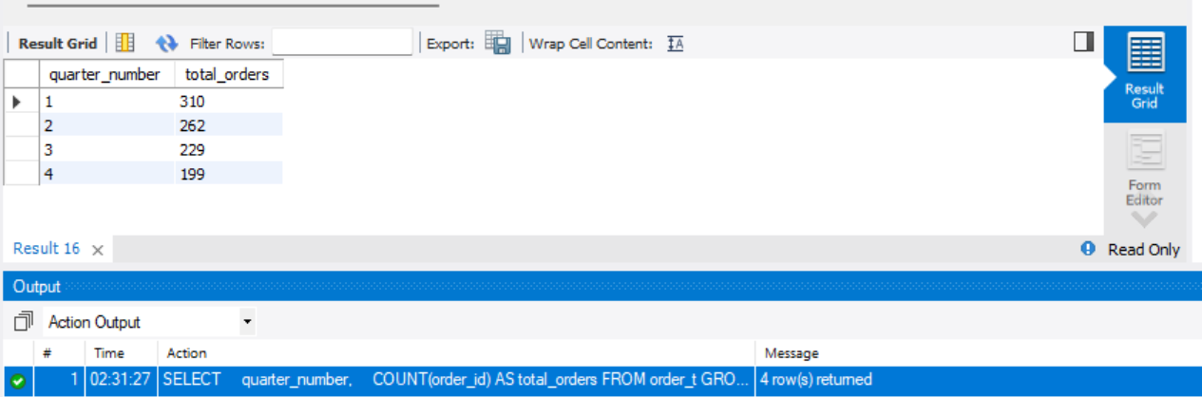
Observation and Insight:
The number of orders decreased every quarter. Orders dropped from 310 in Q1 to 262 in Q2, then to 229 in Q3, and finally to 199 in Q4.
This confirms a steady decline in sales activity throughout the year. The falling order count aligns with the business problem that New-Wheels is losing customer demand, likely due to declining satisfaction and negative feedback.

Question 7: Calculate the net revenue generated by the company. What is the quarter-over-quarter % change in net revenue?
Solution Query:
WITH quarterly_revenue AS (
SELECT
quarter_number,
SUM(quantity * vehicle_price * (1 - discount / 100.0)) AS net_revenue
FROM order_t
GROUP BY quarter_number
)
SELECT
quarter_number,
ROUND(net_revenue, 2) AS net_revenue,
ROUND(
100.0 * (
net_revenue - LAG(net_revenue) OVER (ORDER BY quarter_number)
) / LAG(net_revenue) OVER (ORDER BY quarter_number),
2
) AS qoq_revenue_change_pct
FROM quarterly_revenue
ORDER BY quarter_number;
Output:
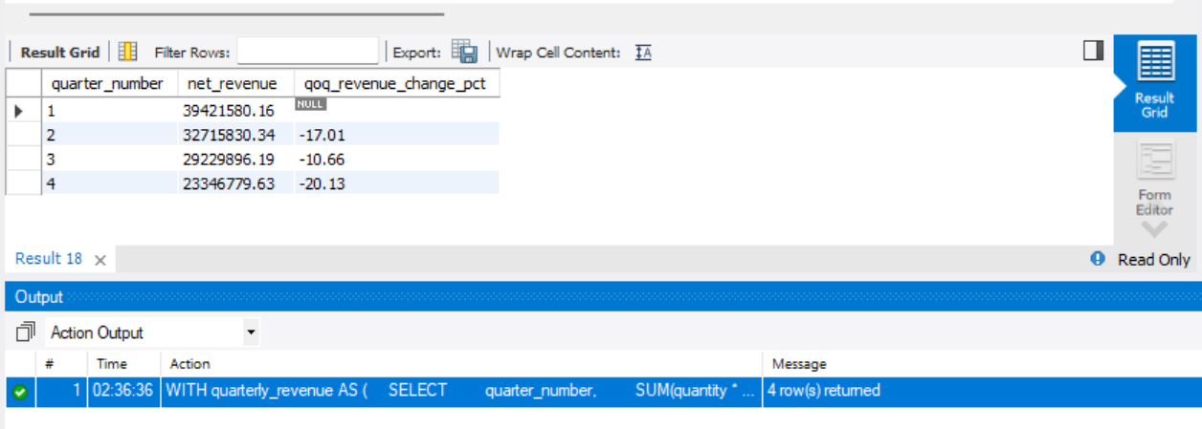
Observation and Insight:
Net revenue declined every quarter. Revenue decreased from 39.42 million in Q1 to 32.72 million in Q2, then to 29.23 million in Q3, and finally to 23.35 million in Q4.
The quarter-over-quarter change also shows continuous negative growth. The largest decline happened in Q4, where revenue dropped by 20.13% compared with Q3.
This indicates a serious revenue problem for New-Wheels. Since both orders and ratings are declining, the revenue fall is likely connected to lower customer trust, poor experience, and reduced demand.
Question 8: What is the trend of net revenue and orders by quarters?
Solution Query:
SELECT
quarter_number,
ROUND(SUM(quantity * vehicle_price * (1 - discount / 100.0)), 2) AS net_revenue,
COUNT(order_id) AS total_orders
FROM order_t
GROUP BY quarter_number
ORDER BY quarter_number;
Output:
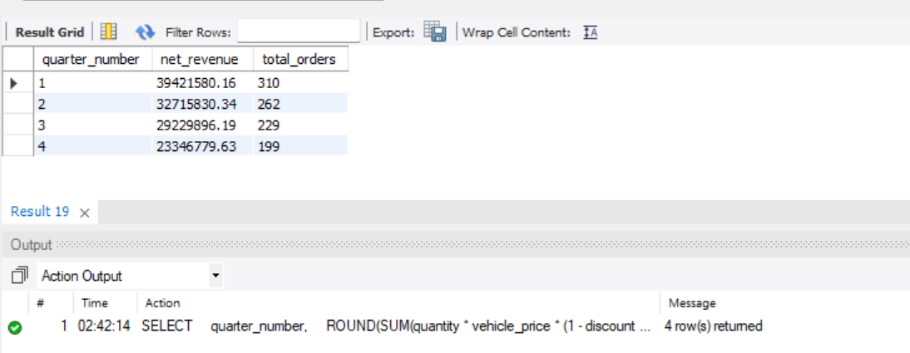

Observation and Insight:

Both net revenue and order count declined quarter by quarter. Revenue dropped from 39.42 million in Q1 to 23.35 million in Q4, while orders dropped from 310 to 199 over the same period.

This shows that the revenue decline is strongly connected to the fall in order volume. The business is not only earning less revenue, but also receiving fewer orders each quarter. New-Wheels should focus on improving customer satisfaction and restoring customer trust to reverse this downward trend.

Question 9: What is the average discount offered for different types of credit cards?
Solution Query:
SELECT
c.credit_card_type AS credit_card_type,
ROUND(AVG(o.discount), 2) AS average_discount
FROM order_t AS o
INNER JOIN customer_t AS c
ON o.customer_id = c.customer_id
GROUP BY c.credit_card_type
ORDER BY average_discount DESC, c.credit_card_type;
Output:
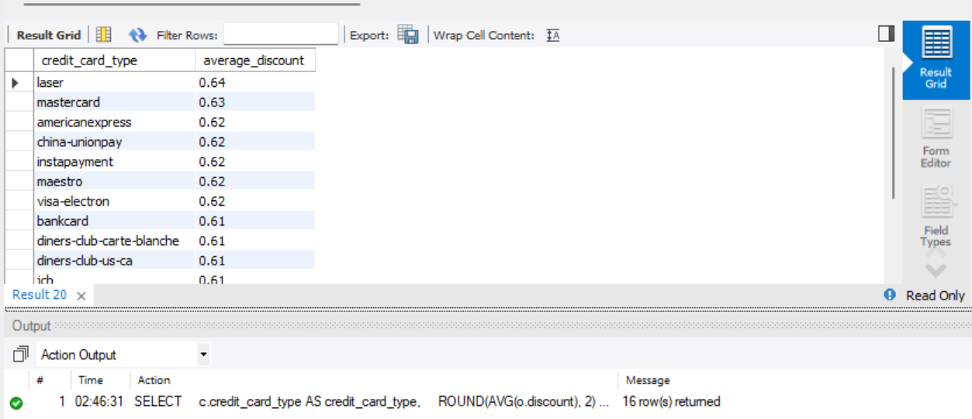
Observation:
The highest average discount was offered for laser cards, with an average discount of 0.64. Mastercard follows with 0.63, while several card types such as American Express, China UnionPay, Instapayment, Maestro, and Visa Electron have an average discount of 0.62.
Insight:
Discounts are fairly similar across credit card types, ranging roughly between 0.58 and 0.64. This suggests that credit card type is not a major driver of discount variation.

Question 10: What is the average time taken to ship the placed orders for each quarter?
Solution Query:
SELECT
quarter_number,
ROUND(AVG(DATEDIFF(ship_date, order_date)), 2) AS average_days_to_ship
FROM order_t
GROUP BY quarter_number
ORDER BY quarter_number;
Output:
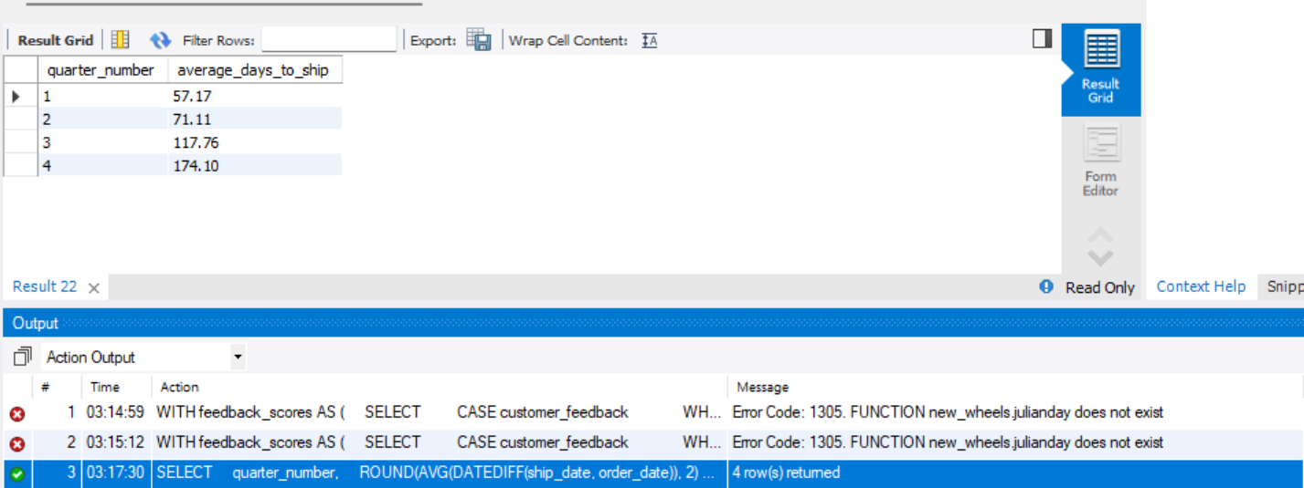

Observation and Insight:

The average shipping time increased sharply across the year. It rose from 57.17 days in Q1 to 71.11 days in Q2, then to 117.76 days in Q3, and finally to 174.10 days in Q4.

This is a major operational issue. The rising shipping delay likely contributed to the drop in customer ratings and the increase in negative feedback. New-Wheels should urgently review its logistics process, shipment partners, and delivery timelines to improve customer experience.

Business Metrics Overview
Total Revenue | Total Orders | Total Customers | Average Rating
124714086.32 | 1000 | 994 | 3.14
Last Quarter Revenue | Last quarter Orders | Average Days to Ship | % Good Feedback
23346779.63 | 199 | 97.96 | 44.10

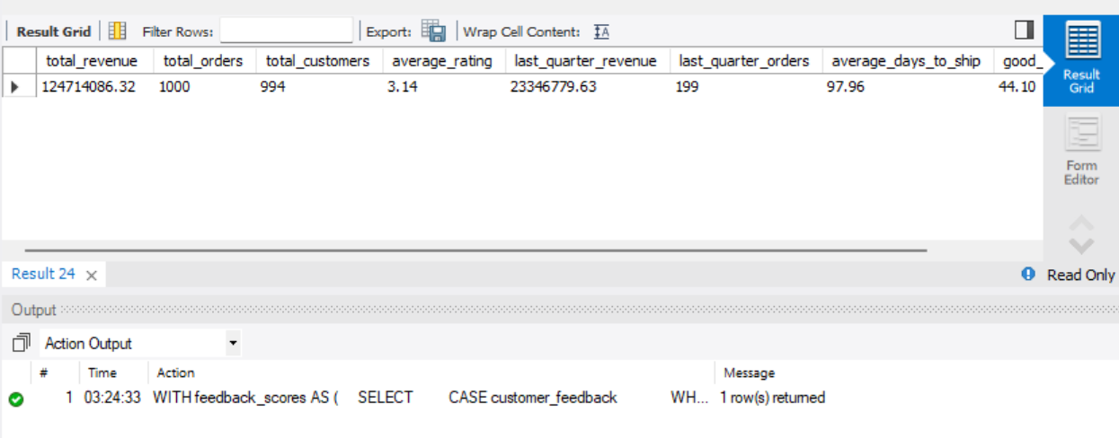

Business Recommendations
New-Wheels generated total net revenue of 124.71 million from 1,000 orders placed by 994 customers. However, the latest quarter performance is weak, with only 199 orders and 23.35 million in revenue. The average customer rating is 3.13, and only 44.10% of feedback is positive, showing that customer satisfaction needs attention. The average shipping time of 97.96 days is high and likely contributing to negative feedback.

Overall Insights
New-Wheels generated a total net revenue of 124.71 million from 1,000 orders placed by 994 customers. However, the quarterly trend shows a clear decline in business performance. Orders dropped from 310 in Q1 to 199 in Q4, while net revenue decreased from 39.42 million to 23.35 million during the same period.
Customer satisfaction also declined steadily. The average rating fell from 3.55 in Q1 to 2.40 in Q4. Negative feedback increased significantly, with Very Bad feedback rising from 10.97% in Q1 to 30.65% in Q4. At the same time, Very Good feedback dropped from 30.00% to 10.05%.
Shipping delays appear to be a major operational issue. Average shipping time increased from 57.17 days in Q1 to 174.10 days in Q4. This sharp increase in delivery time likely contributed to lower customer ratings, more negative feedback, and declining order volume.
Business Recommendations
New-Wheels should urgently improve its shipping and logistics process. Since average shipping time increased sharply across quarters, the company should review shipper performance, identify delay points, and set stricter delivery timelines.
The company should focus on customer experience recovery, especially after-sales service. Since ratings and feedback have declined, New-Wheels should contact dissatisfied customers, resolve complaints quickly, and introduce service follow-ups after delivery.
Inventory planning should be adjusted based on customer demand. Chevrolet, Ford, Toyota, Dodge, and Pontiac are the most preferred vehicle makers, so New-Wheels should maintain stronger availability of these brands.
State-level demand should also guide business planning. High-customer states such as California, Texas, Florida, and New York should receive more focused marketing, inventory, and logistics support.
Finally, New-Wheels should monitor quarterly metrics regularly, especially orders, revenue, average rating, feedback percentage, and shipping time. This will help leadership identify business issues earlier and take corrective action before performance drops further.

